The Impact of Online Teaching on Children’s in this COVID-19 Pandemic

First Author#1, Second Author*2, Third Author#3

*#First-Third Department, First-Third University Address Including Country Name*

[1first.author@first-third.edu](mailto:1first.author@first-third.edu) [3third.author@first-third.edu](mailto:3third.author@first-third.edu)

*\*Second Company Address Including Country Name*

[2second.author@second.com](mailto:2second.author@second.com)

***Abstract*—** The impact of pandemic COVID-19 is visually examined in every sector around this world. The Education Sector is also badly affected sectors of India and the world are lamentably affected by this.[1] The purpose of this study was to identify the limitations of the online teaching and learning process of children at home as a result of the unaccustomed situation in this pandemic COVID-19.[2] Parents visually perceived the quandary was more cognate to a lack of learning discipline at home, more time spent to avail their children's learning at home especially for children below Grade 4 in Primary School, a lack of technology skills, and higher internet bills.[3] The Education sector has fought to survive crises with a different approach and the digitization of challenges to eliminate the threat of Pandemic. Teachers identified more challenges and constraints, including some limitations in the choices of teaching methods that would normally apply in a routine of a face-to-face class, less coverage of curriculum content, lack of technological skills that hamper the potential of e-learning, the lack of electronic resources, which requires more time for electronic content, longer screen time due to creating electronic content and feedback, on Children’s work, more profound and time-consuming elucidation with parents of the children's, the challenge for better coordination with colleague teachers, principals, and a higher Internet bill.[6]

***Keywords—*** *pandemic, COVID-19, education, discipline, primary school, digitization, curriculum, challenges, elucidation.*

**Covid-19’s Staggering Impact On Global Education**

[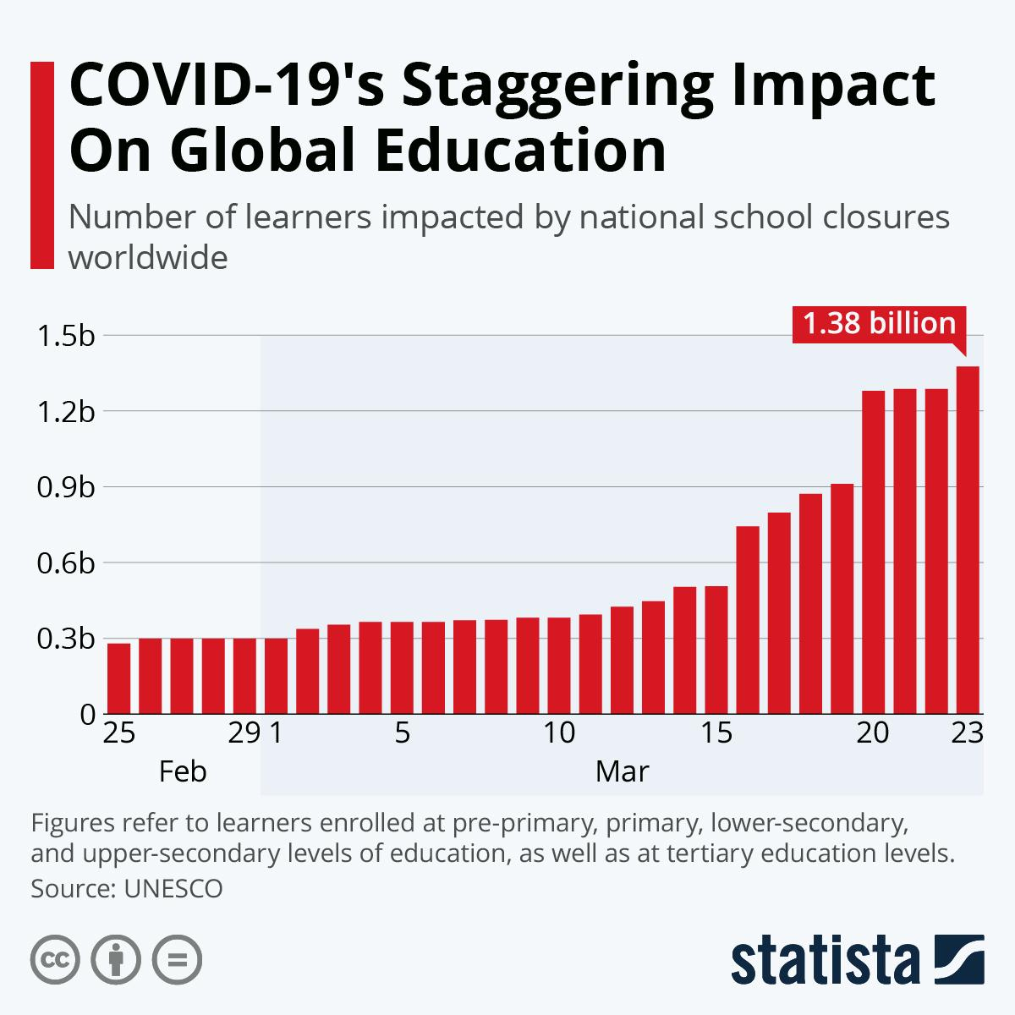](https://www.statista.com/chart/21224/learners-impacted-by-national-school-closures/)

1. **INTRODUCTION**

On February 11, 2020, the World Health Organization (WHO) proposed the official name of the COVID-19 virus, which stands for Coronavirus disease 2019. It was identified for the first time in Wuhan, China on 31 December 2019. The first death caused by COVID-19 occurred in Wuhan, China in 2020.[3] The COVID-19 pandemic has spread throughout the world and has forced human society to maintain social distancing. After observing the pandemic status of the coronavirus, the WHO recommends maintaining social distancing as the first step in prevention. Thus, each country began the containment action to separate the infected persons. The Education sectors, such as schools, colleges, and universities, have been shut down.[7] Classes were suspended and all examinations of schools, colleges, and universities including entrance tests were postponed indefinitely. Suspended classes and all exams at schools, colleges, and universities, including entrance tests, have been deferred indeterminate. So, containment destroyed every student's schedule. A costly hardship for many parents is having several gadgets for themselves and their children. Children are instructed to remain at home, making this year's "Tet Holiday" the longest holiday in history. When a child is trapped inside due to the Coronavirus, switching from traditional classrooms to online learning appears to be the only and most effective way to keep 0kids learning. While studying online may not be the ideal option for every kid, knowing the benefits and cons will help determine whether distance learning is appropriate for them. Also, too much online learning pressure and staring at screens for long periods is feared by parents as a way to harm children's vision and health.[4]

1. **METHODOLOGY**

This study used the quantitative research method to the descriptive survey design. The study has been conducted in Ghana, western Africa, with an estimated population of over 30 million per the census of 2010. (GSS, 2010). Since the breakdown allowed no personal interaction with people, the researcher used the online survey to reach the respondents.[3] To identify conceptual and operational definitions of the research field, a literature search has been carried out, specifically information about online learning during the COVID-19 pandemic. Data analysis follows known analytical techniques for observational items and indicators Data analysis (Braun & Clarke, 2006)[2] In most parts of the world, there have been lock-downs and people have been invited to work. Some nations have even deployed their military to enforce limitations on coronavirus and minimize the number of greedy persons.[4] The current study collects data and information from several reports from national and worldwide pandemic authorities on the COVID-19. Different genuine websites collect information. Some journals and e-containers are referred to on the influence of COVID-19 on the school system.[5]

1. **RESEARCH RESULT**

The study aimed at gathering information on the influence of the Covid-19 epidemic in the Primary Schools’ learning and teaching activities. The declarations are the English version of the original answers without a modification of the participants.[1] One of those respondents (R6) said that "children are compelled to learn on a distance without sufficient infrastructure and resources at home" (R6). "Students have no distant learning culture because the learning method adopted to date is face-to-face," another responder (R5) noted. "Not all teachers can use Internet or Social Media as a learning tool."

1. **CONCLUSION**

Learning and teaching in the field of education for children have changed dramatically as a result of the Covid-19 epidemic. Even if the COVID-19 issue drags on, there is a pressing need to maximize the use of online platforms so that students not only learn in the classroom but are also prepared for the future digitally oriented world in which they will be living.[4] During a pandemic, India should create innovative methods to guarantee that all children have access to schooling COVID-19. For successful delivery of education, Indian policy must involve persons from varied backgrounds, including rural regions, marginalized, and minority groups.[6] Teachers at the school battle with the sudden change that causes a learning and teaching disruption. At home, not all parents are prepared to make home learning easier.[1] Confining measures such as schools and activity centers, which close down for longer times, subject children and young people to the weakening effect of soleness, anxiety, and insecurity on educational, psychological, and developmental achievement. The usage of the internet and social networks compulsively puts individuals in increased danger. No environmental variation shall be utilized by children and adolescents with mental health problems.[6]

1. **ACKNOWLEDGEMENT**

We like to appreciate the work done by Mrs. Meenakshi Seth and Mr. Prakhar Bhanu to improve the manuscript language. The writers also thank the CORONA Warriors i.e. the Health Care Workers for their selfless and huge contribution to the human race.[6] This study, therefore, recognizes that it can hurt to decide to shut down the worldwide Coronavirus schools but the rate of propagation and the hazards of the COVID-19 pandemic is reasonable to take into account. Coronavirus' extraordinary school closures remain teaching and a warning for the entire globe, especially those who still need to accept or adopt new technology for learning which supports online or remote education.[4]

1. **REFERENCES**
2. Putri, R. S., Purwanto, A., Pramono, R., Asbari, M., Wijayanti, L. M., & Hyun, C. C. (2020). Impact of the COVID-19 pandemic on online home learning: An explorative study of primary schools in Indonesia. *International Journal of Advanced Science and Technology*, *29*(5), 4809–4818.
3. Rasmitadila, Aliyyah, R. R., Rachmadtullah, R., Samsudin, A., Syaodih, E., Nurtanto, M., & Tambunan, A. R. S. (2020). The perceptions of primary school teachers of online learning during the covid-19 pandemic period: A case study in Indonesia. *Journal of Ethnic and Cultural Studies*, *7*(2), 90–109. https://doi.org/10.29333/ejecs/388
4. *European Journal of Education Studies THE IMPACT OF COVID-19 ON LEARNING -*. (2020). 88–101. https://doi.org/10.5281/zenodo.3753586
5. Onyema, E. M. (2020). Impact of Coronavirus Pandemic on Education. *Journal of Education and Practice*, *11*(13), 108–121. https://doi.org/10.7176/jep/11-13-12
6. Jena, P. K. (2020). Impact of Pandemic COVID-19 on Education in India. *International Journal of Current Research (IJCR)*. https://doi.org/10.31235/osf.io/2kasu
7. Singh, S., Roy, D., Sinha, K., Parveen, S., Sharma, G., & Joshi, G. (2020). Impact of COVID-19 and lockdown on the mental health of children and adolescents: A narrative review with recommendations. *Psychiatry Research*, *293*(May),113429.https://doi.org/10.1016/j.psychres.2020.113429
8. Ghosh, R., Dubey, M. J., Chatterjee, S., & Dubey, S. (2020). Impact of COVID-19 on children: Special focus on the psychosocial aspect. *Minerva Pediatrica*, *72*(3), 226–235. https://doi.org/10.23736/S0026-4946.20.05887-9